SHAREENA MALIK IFTEKHAR MALIK KHAN  Contact No : 7517899870  Email Id : shareena2308@gmail.com  Address : “786 Manzil”, In front of – Uttangle  Mangal Karayala, Adarsh Colony,  Gaurakshan Road, Akola | 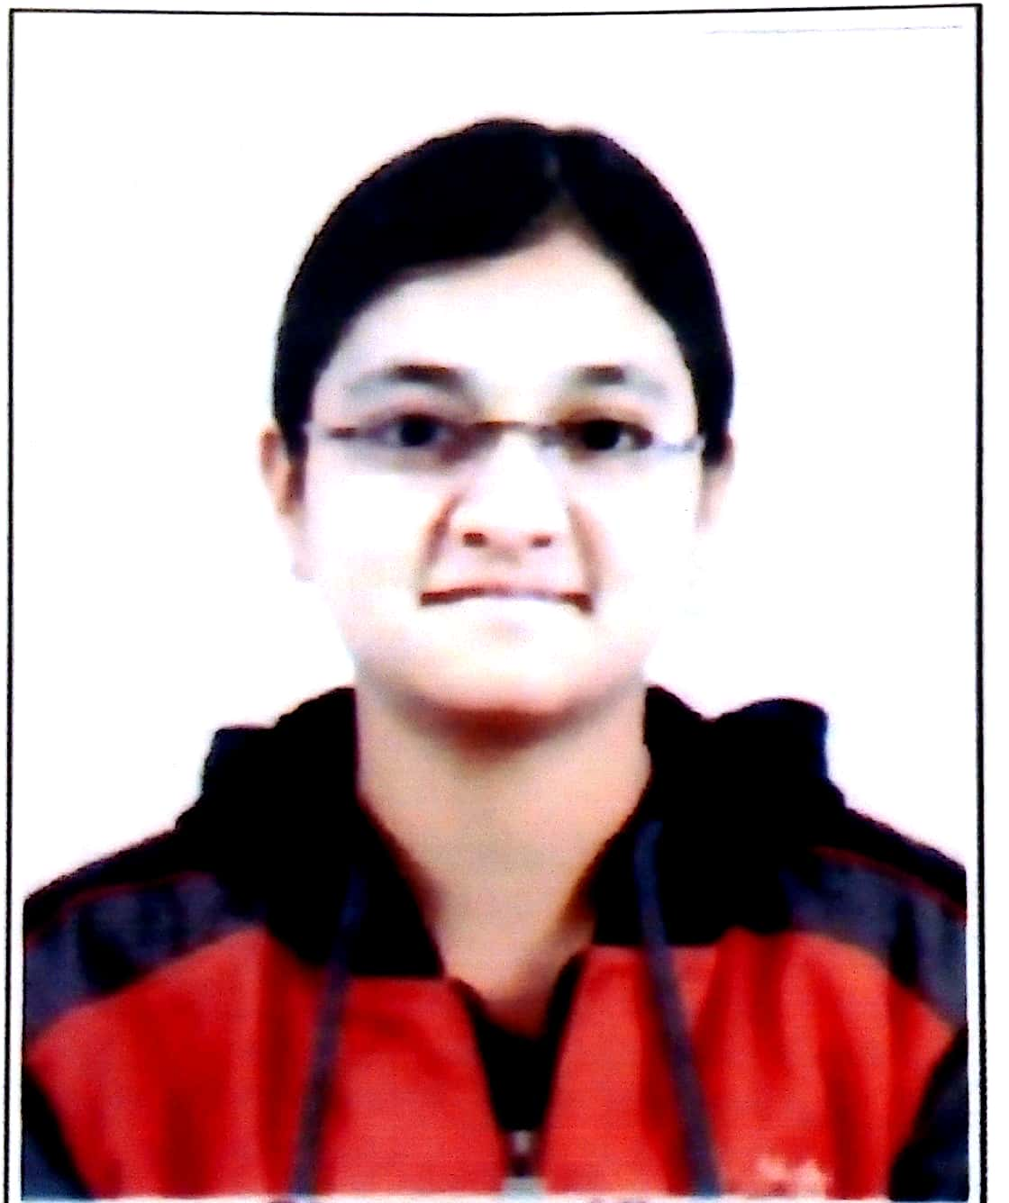

Career Objective: To seek different opportunities to enhance my career and skills in
corporate sector to build a successful future.

Educational Qualification

Degree/Course | Name of Institute | Board/University | Marks Obtain | CGPA | Year of Passing
Bachelor of Engineering in Computer Science and Engineering | Shri Shivaji College Of Engineering & Technology Akola | Sant Gadge Baba Amravati University, Amravati | 62.30 | 7.57 | 2019
Higher Secondary Certificate Examination | Mount Carmel Science Junior College Akola | Maharashtra State Board of Secondary & Higher Secondary Education ,Pune | 69.85% | NA | 2015
Secondary School Certificate | Mount Carmel Secondary and Higher Secondary School, Akola | Maharashtra State Board of Secondary and Higher Secondary Education, Pune | 76.40% | NA | 2013
Technical Skills
- Programming Languages : C,CPP,JAVA
- Web Technology : HTML
- Databases : MySql
- Project Done : HTML.
Project Details: Major Project :
- Title : E-BUSS PASS
Duration : November 18 To April 19
Description : E-Buss Pass is web application in which QR code will be used to check authentication of the passenger. To develop a web application using which every user will be able to get bus timetable and pass information from anywhere. To implement payment gateway in bus pass system which enables users to do payment online
Mini Project :

- Title: Illusionist SmartPhones
Duration : August 16 to October 16
Description : Project based on HTML & CSS which Showcase difference between Mobile Operating System i.e. Android , Microsoft and IOS .

Co-Curricular Activities
- Participated in Googler in TECHNO-thlon 2016 .A National Level Technical Event held on 11th February 2016
- Participated in Mock Interview Competition held at College Of Engineering & Technology, Akola
- Active participation in Anchoring at Shivgandha 2018

Hobbies
- Playing Games
- Internet Surffing

Personal Detail
      - Gender : Female
      - Date of Birth : 23rd August 1997
      - Father's Name : Iftekhar Malik Khan
      - Father's Occupation : Lawyer
      - Linguistic Ability : English, Hindi, Marathi, Urdu
      - Nationality : Indian
      - Personal Strength : Management

Declaration: I hereby declare that all the details furnished above are true to the best
of my knowledge and belief.

Date : 18/08/2018 Signature :

